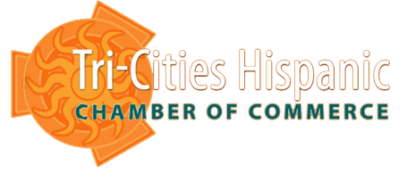
15th Annual Mariachi & Latino Music Festival
Sunday, June 26, 2022
Columbia Park, Kennewick WA

BOOTH REGISTRATION FORM
Business Name:

Representative Name:

Address: | City: | Zip Code:
E-Mail: | Web:
Phone: | Alternate Phone:
Additional Comments:

PLEASE CHOOSE YOUR LEVEL OF PARTICIPATION
Food Sales (Please describe item(s):
Non-Profit $150 _____ Regular Booth $250 _____ Food Vendor $350 _____

Please check here if for electricity access: _____
Due to COVID, vendor fees have been reduced.

Are you interested in promoting your business in the PROGRAM ADS?
_____ Front Cover inside full page (4.5 in. wide X 7.5 in. tall): $400.00
_____ Back Cover full page 4.5 in. wide X 7.5 in. tall): $300.00
_____ Full page (4.5 in. wide X 7.5 in. tall): $250.00
_____ Half page (4.5 in. wide X 3.5 in. tall): $ 150.00
_____ Quarter page (2 in. wide X 3.5 in. tall): $50.00
Total Payment Due: $____________

Pre-payment is required. Please fill out the Credit card information below or make checks payable to: TCHCC and mail to P.O. Box 3938 Pasco, WA 99302
BILLING INFORMATION
Mastercard_____ Visa_____ Check_____ Cash_____
Credit Card Number: ___________________________ Expiration Date: _________________________
Name on Card:________________________________________________________________________
Address (if different than above):_________________________________________________________
Authorized Signature:___________________________________________________________________

For more information, please call TCHCC at (509) 542-0933 or email us at infotchispanicchamber.com
P.O. BOX 3939
PASCO, WA 99302

